PROBLEM DEFINITION AND PLANNING
- Problem Statement
Rapid growth of online news platform has resulted in a massive increase in the number of news articles published everyday. Manually categorizing these articles into topics such as politics , sports, business, technology and all is time consuming, inefficient and prone to errors. Incorrect classification effect content organization, information retrieval and user experience.
To address this challenge, an automated News Category Classification System is required. The system will utilize Natural Language Processing (NLP) and Machine Learning techniques to analyse the textual content of news articles and accurately assign them to predefined categories. This will improve classification efficiency, reduce manual effort, and enable effective management of large volumes of news content.
- Data Source
The dataset that is being used is collected from Kaggle. The dataset if HuffPost News Category. This dataset contain 210K news headlines collected between 2012 to 2022. This is one of the biggest news dataset and can serve as a benchmark for variety of computational linguistic task.
The dataset contain the following attributes:
- Category
- Headline
- Author
- Link
- Short Description
- Date
Link to the Dataset: https://www.kaggle.com/datasets/rmisra/news-category-dataset

DATA COLLECTION AND LOADING
As Kaggle is used for the dataset, dataset download can be achieved using kagglehub. Dataset can be downloaded in the form of zip file as well. But for automatic dataset download kagglehub is used. It is a library which provides a simple way to interact with Kaggle resources such as datasets, models, notebook outputs in python.
This library also integrates natively with the Kaggle notebook environment. This means the behaviour differs when you download a Kaggle resource with kagglehub in the Kaggle notebook environment:
- In a Kaggle notebook:
  - The resource is automatically attached to your Kaggle notebook.
  - The resource will be shown under the "Input" panel in the Kaggle notebook editor.
  - The resource files are served from the shared Kaggle resources cache (not using the VM's disk).

- Outside a Kaggle notebook:
  - The resource files are downloaded to a local cache folder.

Install the kagglehub package using pip:
pip install kagglehub
Download the dataset to the project using this code:
import kagglehub
path = kagglehub.dataset_download("rmisra/news-category-dataset")
print("Path to dataset files:", path)
Import the downloaded dataset:
import pandas as pd
import json
path+="/News_Category_Dataset_v3.json"
df = pd.read_json(path, lines=True)

Data received after inspecting the dataset:
- df.shape There are a total of 209527 rows and 6 columns.
- df.head() Shows the first 5 records of the dataset
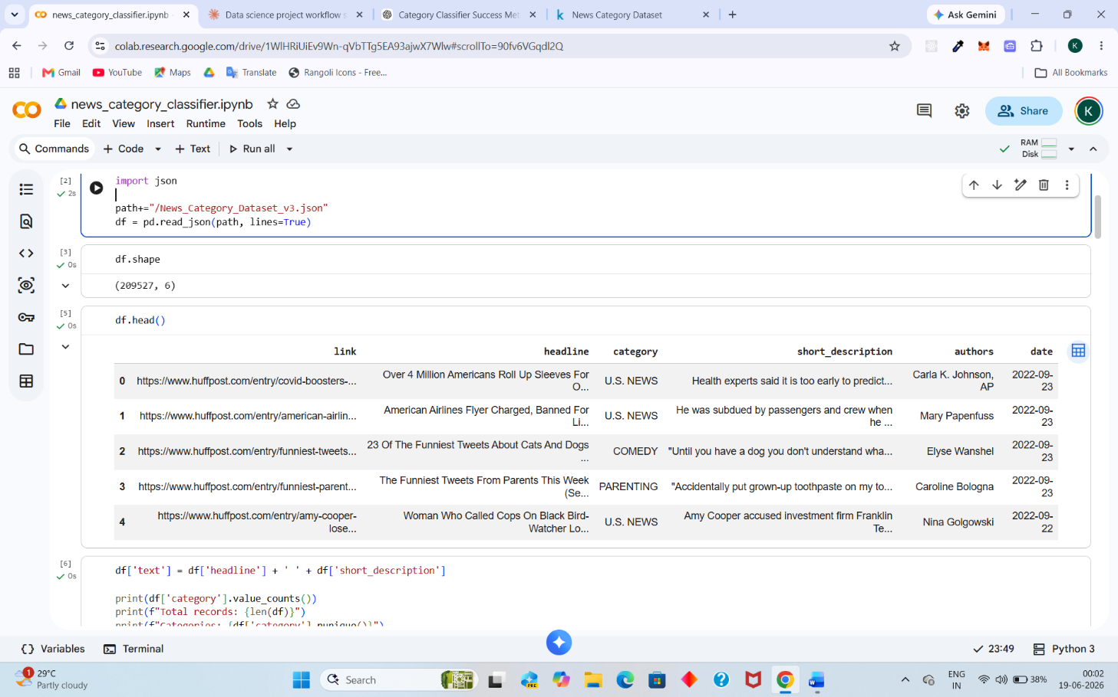
- df['category'].value_counts() Lists all the category with their count
category
POLITICS 35602
WELLNESS 17945
ENTERTAINMENT 17362
TRAVEL 9900
STYLE & BEAUTY 9814
PARENTING 8791
HEALTHY LIVING 6694
QUEER VOICES 6347
FOOD & DRINK 6340
BUSINESS 5992
COMEDY 5400
SPORTS 5077
BLACK VOICES 4583
HOME & LIVING 4320
PARENTS 3955
THE WORLDPOST 3664
WEDDINGS 3653
WOMEN 3572
CRIME 3562
IMPACT 3484
DIVORCE 3426
WORLD NEWS 3299
MEDIA 2944
WEIRD NEWS 2777
GREEN 2622
WORLDPOST 2579
RELIGION 2577
STYLE 2254
SCIENCE 2206
TECH 2104
TASTE 2096
MONEY 1756
ARTS 1509
ENVIRONMENT 1444
FIFTY 1401
GOOD NEWS 1398
U.S. NEWS 1377
ARTS & CULTURE 1339
COLLEGE 1144
LATINO VOICES 1130
CULTURE & ARTS 1074
EDUCATION 1014
- len(df) Counts and display the total number of records present. There are a total of 209527 records
- df['category'].nunique() Calculates the no of unique value in the specific column. By using this code the total number of categories present is printed. There are a total of 42 category present in the dataset.
- df.isnull().sum() Gets the number of null value present. There is no null values or empty space present in the dataset.
- df.duplicated().sum() Gets the number of duplicate values present in the dataset. This dataset contain 13 duplicate values.
- df = df.drop_duplicates() Drops all the duplicate values present from the dataset.

EXPLORATORY DATA ANALYSIS
- Univariate Analysis
It is the simplest form of quantitative data analysis where a single variable is observed and analysed at a time.
Its primary purpose is to describe the data summarize its distribution and identify its pattern like central tendency, spread, outliers before moving to complex multivariate comparision.
In this dataset there are 2 columns where we can perform analysis:
- Category
- Date
Univariate analysis is performed differently for different data type. There are two type of datatype present :
- Numerical
- Categorical
Here both of the column that are used for analysis are of categorical data type.

